Algebra 1: Unit 4, Lesson 11

- The graphs of $f(x)$ and $g(x)$ are shown.
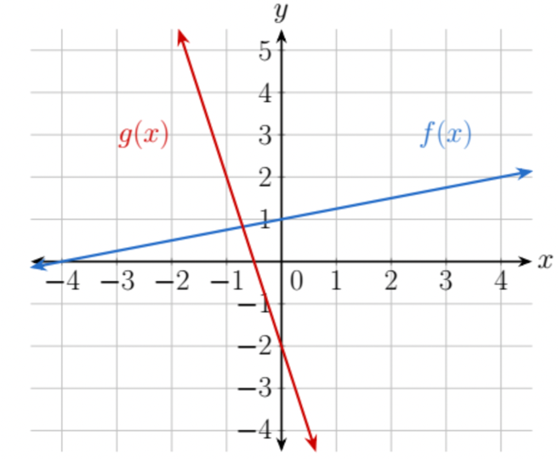
What is the slope of $g(x)$?
-4

- What is the slope of the line that is perpendicular to $y=\frac{3}{4}x+2$.
$$-\frac{4}{3}$$

- Write the equation of a line that is perpendicular to a line that has a slope of $-\frac{2}{9}$ and contains the point $(12,32)$ in slope intercept form.

$$y=\frac{9}{2}x-22$$

